**Mobile air purifiers: OurAir SQ 1750 for large rooms up to 140m²**

[Technical data](https://airfiltration.mann-hummel.com/en/products/room-air-purifiers-virus/ourair-sq-1750.html#ourair-sq-1750-technical-data) [Request](https://airfiltration.mann-hummel.com/en/products/room-air-purifiers-virus/ourair-sq-1750.html#request) [Downloads](https://airfiltration.mann-hummel.com/en/products/room-air-purifiers-virus/ourair-sq-1750.html#ourair-sq-1750-downloads) [Contact](https://airfiltration.mann-hummel.com/en/products/room-air-purifiers-virus/ourair-sq-1750.html#ourair-sq-1750-contact)

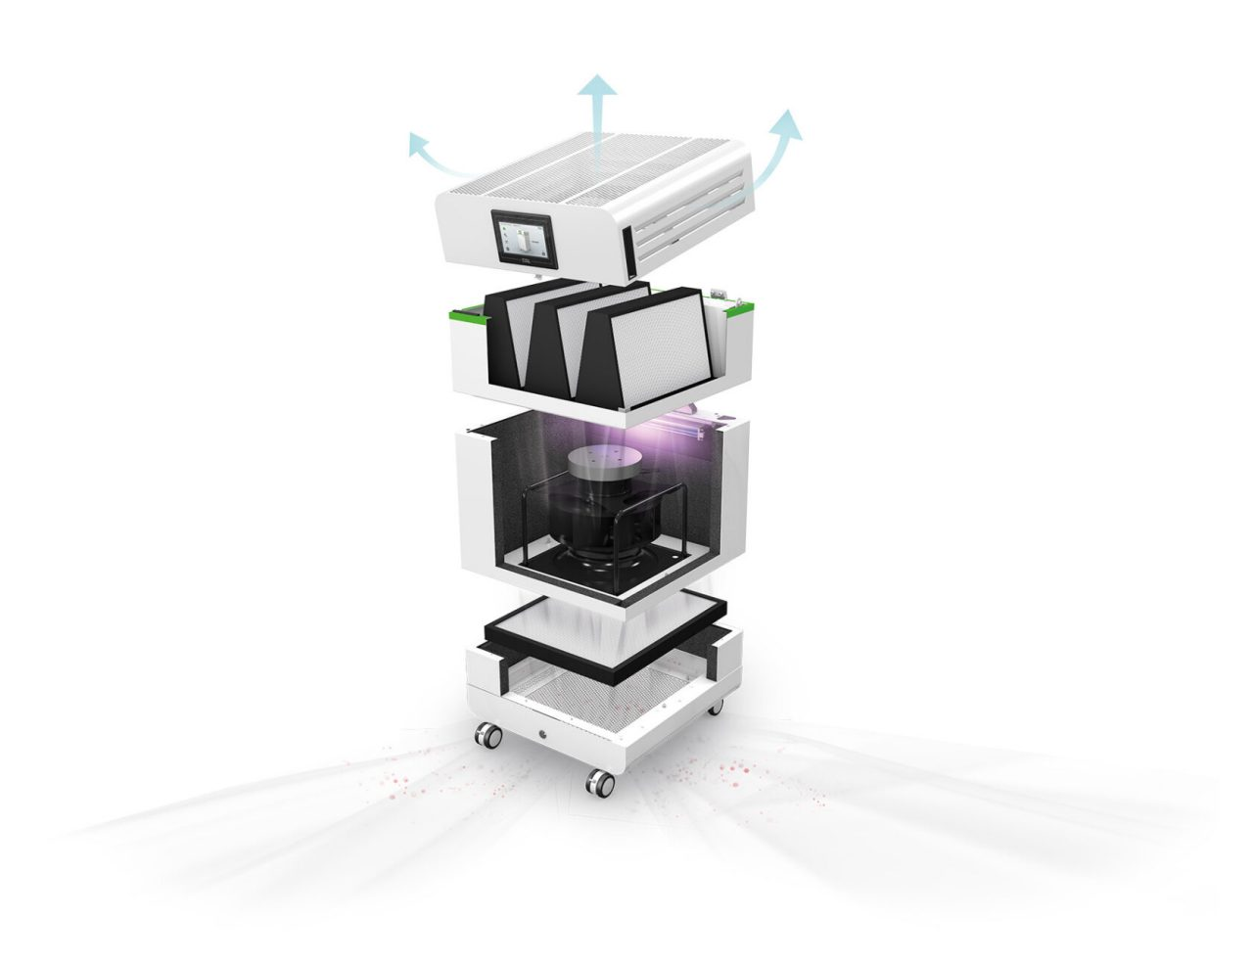

**OurAir SQ 1750 (successor to TK 850)**

* [**Scientifically proven effectiveness**](https://airfiltration.mann-hummel.com/en/insights/studies/air-purifier-test.html)
* Suitable for larger rooms up to **140m²**
* Fitted with HEPA H14* filters that **capture >99.995% of viruses and mutations**
* Works **quietly** at **low energy consumption**
* **Portable** – wheel it between rooms
* **Easy to install:** simply plug it in (230 V power source)
* Long-term solution after Corona and availability of vaccinations
* Size: 0,65 x 0.65 x 1.25m
* Net weight: 85kg
* Price: 2.900 EUR plus VAT

* according to ISO 29463 and EN 1822

**Sound output and technical data**

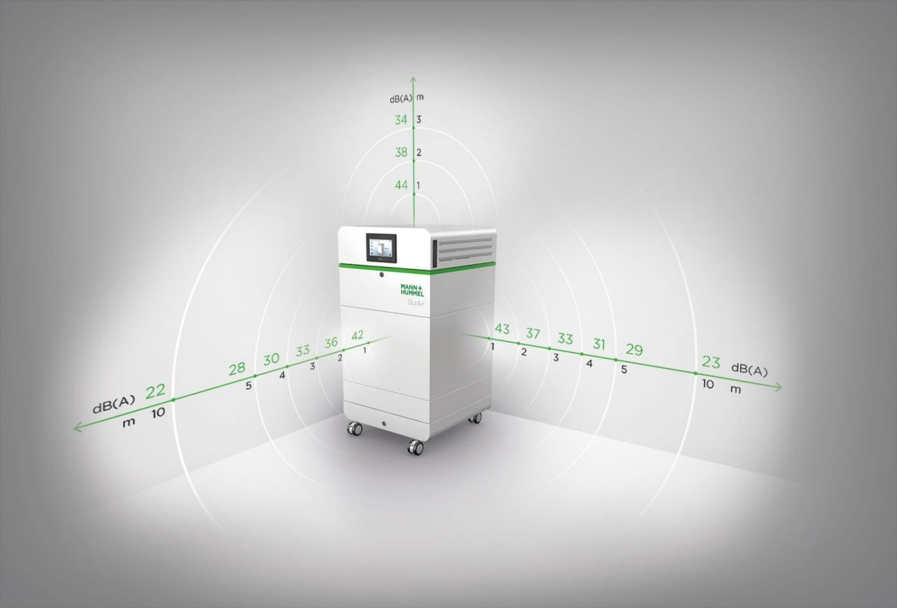

| **Technical Data** | **OurAir SQ 1750** |
| --- | --- |
| Power Consumption | 75 W @ average operation speed (850 m³/h); 320 W @ maximum (1750 m³/h) |
| Air Flow Rate | 400 – 1750 m3/h |
| Air Exchange Rate | ~ 5 times/hour (140 m2 room) ~ 6 times/hour (120 m2 room) |
| Cabinet Material | Powder-coated steel – 1.5 mm thick |
| Screen | PIN-protected 7" LCD touch screen |
| Circuit Breaker | Integrated – 4 amp |

**Questions to mid-size room air purifiers**

**Mid-size room air purifier: Benefits at a glance**

As we learn more about how [**COVID-19**](https://airfiltration.mann-hummel.com/en/products/room-air-purifiers-virus/air-purifier-against-covid-19.html) spreads, experts are increasingly focused on transmission via close- and long-range airborne particles, and droplets resulting from coughs or sneezes. The fact that the virus can spread through the air means the advantages of clean air are clear: **reduced risk of infections**, and **peace of mind** that your building is as safe as possible.

This means portable air filtration systems like those designed by our expert team at MANN+HUMMEL give you a suitable solution in the fight against [**COVID-19**](https://airfiltration.mann-hummel.com/en/products/room-air-purifiers-virus/air-purifier-against-covid-19.html) and other airborne contaminants. By frequently replenishing the air indoors, our air purifiers help keep you healthy.

The effectiveness of the **OurAir TK 850 (Predecessor model of the SQ 1750)** with H14 filter in extracting virtually all traces – **99.995%** – of damaging particulates was **proven** in a [**study by Professor Achim Dittler of the Karlsruhe Institute of Technology**](https://airfiltration.mann-hummel.com/en/insights/studies/air-purifier-test.html).

With the OurAir SQ 1750 you get **additional benefits** too.

* **Improved indoor air quality** and the removal of nearly 100% of harmful particulates from your room
* **Easy to use –**simply plug in and breathe easy
* **Energy efficient**performance keeps running costs low
* Offers**flexible solutions** thanks to its great portability which makes it easy to move from room to room, and you can store it away easily
* Thanks to the **neutral design** this compact air purifier works with any interior
* **Quiet** operation means minimal noise emissions
* Enables your business to function safely by providing **virus-free air** for colleagues and customers

The **OurAir SQ 1750** portable air cleaner is suitable for use in **schools, restaurants, pharmaceutical facilities, gyms, offices, bars, airports, shopping centers** and **many other places.**

