**The mobile air purifier for large rooms up to 200 m²: OurAir SQ 2500**

[Technical data](https://airfiltration.mann-hummel.com/en/products/room-air-purifiers-virus/ourair-sq-2500.html#sq-2500-sound-output-technical-data) [Online shop & request](https://airfiltration.mann-hummel.com/en/products/room-air-purifiers-virus/ourair-sq-2500.html#shop-request) [Downloads](https://airfiltration.mann-hummel.com/en/products/room-air-purifiers-virus/ourair-sq-2500.html#sq-2500-downloads) [Contact](https://airfiltration.mann-hummel.com/en/products/room-air-purifiers-virus/ourair-sq-2500.html#sq-2500-ourair-contact)

**Large spaces bring major challenges**: **Viruses, bacteria, fine dust and other allergens and pollutants**in high concentrations **endanger the health of the people** who work, eat and live in them. It's not just the COVID-19 pandemic necessitates restrictions around the world - especially for events held in large spaces. A host of other airborne viruses and pathogens can trigger infections and other ailments too.

MANN+HUMMEL offers a holistic solution for**clean and virus-free air**in large spaces that don't have adequate ventilation systems. **60 years of experience in air filtration at cleanroom level**and our experts’ concentrated know-how went into the development of our **mobile air purifier for rooms up to 200 sqm in size**. The result: The powerful, energy-efficient mobile room air purifier OurAir SQ 2500.

**OurAir SQ 2500: Advantages at a glance:**

* **Scientifically proven effectiveness**
* For**large rooms up to 200 m²**(5 air changes per hour)
* **Highly efficient HEPA-H14* filters**remove more than 99.995% of viruses and mutations, bacteria, allergens and other pollutants from the air
* Also **effective against odors**and harmful gasses thanks to optional added activated carbon filter
* **Whisper-quiet** and **energy-saving**
* Particularly **high volume flow**with up to 2500 m³ air flow per hour
* **Extremely stable**thanks to 1.5 mm steel powder coating
* **Easy installation**thanks to 230 V mains connection
* **Long-term solution** that filters not only coronaviruses but also other viruses such as influenza
* Size: 1.004 x .0523 x 1.05 m

*High Efficiency Particulate Air, according to DIN ISO 29463 and EN 1822

Would you like to **buy your OurAir SQ 2500 right away**? Are you looking for [replacement filters for an OurAir purifier](https://shop.mann-hummel.com/en/ourair/accessories) or do you still have **questions**?

**Efficacy of MANN+HUMMEL mobile air purifiers scientifically confirmed**

The Karlsruhe Institute of Technology (KIT) [has tested the OurAir air purifiers for medium-sized and big rooms](https://airfiltration.mann-hummel.com/en/insights/studies/air-purifier-test.html) and has proven their effectiveness. By using a mobile air purifier from MANN+HUMMEL, the aerosol concentration in the room air is drastically reduced after only a few minutes and approaches zero in the further course. This means **almost 100% less air pollution**. The study confirms a **significant reduction in harmful particles indoors** - and, as a consequence, a **reduced risk of infection**.

**The large air purifier OurAir SQ 2500 effectively separates the useful from the harmful**

The industrial air purifier **OurAir SQ 2500** is ideal for cleaning the air in **large rooms of up to 200 m²**where ventilation systems with virus filters are not installed or where ventilation systems need an upgrade. Whether in office buildings, restaurants, airports, medical facilities or gyms, the highly effective filters reduce viruses and bacteria wherever many people congregate indoors and the air cannot be sufficiently exchanged.

Despite its strong filtration performance, the OurAir SQ 2500 is **surprisingly quiet and energy-saving**:

**Sound output and technical data**

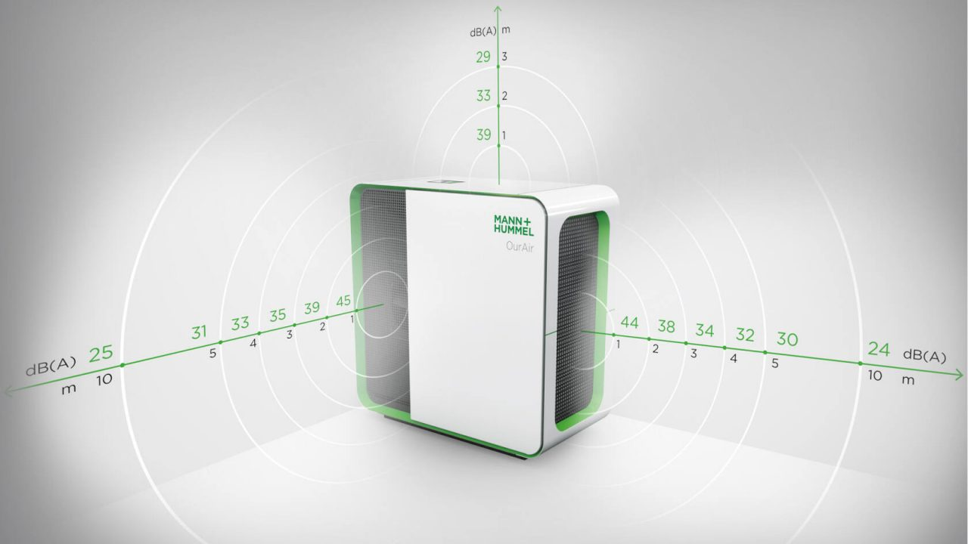Noise level at various distances and directions with an air flow of 1.250m³/h and a damper fitted

* 250 to 2500 m³ of air flow per hour
* A five times air change rate for a 200 sqm room and a six times rate for a 170 sqm room
* With retrofitted silencer: Only 45 dB(A) sound level at average output, measured at one meter distance from the air purifier. At a distance of 5 meters, barely perceptible at approx. 30 dB(A)
* 110 W power consumption at average operation of 1250 m³/h

**HEPA H14 filter and activated charcoal filter for virus-free, clean air**

The HEPA H14 filter in the OurAir SQ 2500 is an effective virus filter. Since it also removes other pollutants from the air, it is our long-term solution for better air quality in large spaces. Whether for industry, commercial buildings or leisure facilities, the certified [HEPA-H14 filter](https://airfiltration.mann-hummel.com/en/products/air-filters/high-efficiency-air-filters.html) separates**more than 99.995%** of viruses and their mutations, bacteria, allergens, fine dust and other pollutants in the air.

If the **OurAir SQ 2500**is additionally equipped with an optional **activated carbon filter from MANN+HUMMEL**, it can also reduce organic odors or smoke from large and/or high rooms. For all-round effective air filtration and a **better quality of life**.

**Air purifier for small rooms up to 40 sqm and large rooms from 140 sqm to 200 sqm**

**Clean and virus-free air** is crucial in combating infections and allergies caused by airborne allergens. We have all witnessed this since the beginning of the COVID-19 pandemic and the attempt to contain the virus. Tests have proven: Our [air purifiers are effective against COVID-19](https://airfiltration.mann-hummel.com/en/products/room-air-purifiers-virus/air-purifier-against-covid-19.html).

**MANN+HUMMEL OurAir air purifiers are pioneering solutions for all rooms**. They provide protection in classrooms and offices, medical practices and restaurants, factories, recreational facilities and much more. You can find the right [HEPA room air purifiers](https://airfiltration.mann-hummel.com/en/products/room-air-purifiers-virus.html) for any room size:

* The [OurAir SQ 2500](https://shop.mann-hummel.com/en/ourair/ourair-sq-2500.html) is the HEPA air purifier for big rooms up to 200 sqm (or 2000 square feet). To ensure modern filtration in even extra-large areas, use several air purifiers as modules.
* The [OurAir SQ 500 air cleaner for small rooms up to 40 sqm](https://airfiltration.mann-hummel.com/en/products/room-air-purifiers-virus/ourair-sq-500.html) (or 400 sq ft) and the [OurAir SQ 1750 for medium-sized rooms up to 140 sqm](https://airfiltration.mann-hummel.com/en/products/room-air-purifiers-virus/ourair-sq-1750.html) (equivalent to rooms of 500, 1000 or 1500 sq ft in size) are ideal for more compact room sizes.
* For large open spaces outdoors we provide our efficient [outdoor air purifiers](https://airfiltration.mann-hummel.com/en/products/outdoor-air-purifiers.html).

In the [OurAir online store](https://shop.mann-hummel.com/en/ourair/) you will also find the matching [replacement filters for OurAir room air purifiers](https://shop.mann-hummel.com/en/ourair/accessories) - from HEPA H14 virus filters to activated carbon filters.

